**Vehicle suspension System**

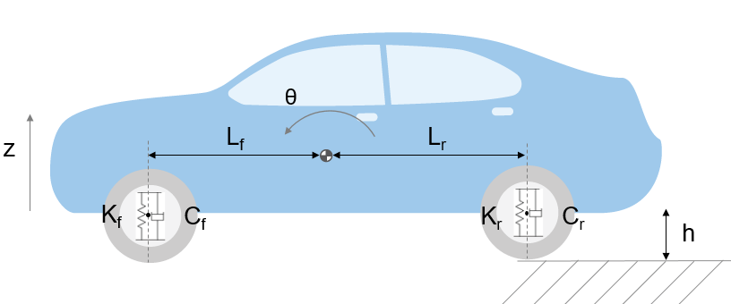

Force exerted by the spring of front suspension due to the bounce of the car is,

Ffs1 = -2Kf (Z+H)

Force exerted by the suspension induced pitch moment on the suspension

Ffs2 = 2Kf  Lf θ

Damping force in front suspension due to the bounce

Ffc1 = -2Cf

Damping force in front suspension due to the pitch

Ffc2 = 2Cf Lf

Total Upward force by front suspension is given by

Ff = - 2Kf (Z+H) + 2Kf  Lf θ - 2Cf + 2Cf Lf  ………….. **1**

Force exerted by the spring of rear suspension due to the bounce of the car is,

Frs1 = -2Kr (Z+H)

Force exerted by the suspension induced pitch moment on the suspension

Frs2 = -2Kr  Lr θ

Damping force in rear suspension due to the bounce

Frc1 = -2Cr

Damping force in rear suspension due to the pitch

Frc2 =- 2Cr Lr

Total Upward force by rear suspension is given by

Fr = - 2Kf(Z+H) -2 Kf  Lf θ - 2Cf -2 Cf Lf ……….. **2**

The pitch contribution to the front suspension is given by

𝑀𝑓 = −𝐹𝑓𝐿𝑓

The pitch contribution to the rear suspension is given by

𝑀𝑟 = 𝐹𝑟𝐿𝑟

Relation between moment of inertia of the body and rate of change of pitch angle is

𝐼𝑦𝑦 = 𝑀𝑓 + 𝑀𝑟 + M ……… **3**

Resolving the forces and moments that results in body motion using Newton’s second law,

mb = Ff + Fr – mbg ……… **4**

Here,

Kf and Kr are the spring constants of the front wheels and rear suspension springs respectively.

Cf and Cr are the damping rates of front and rear suspension respectively.

Lf and Lr are the distance between the centre of gravity to front and rear suspension respectively.

θ and are the pitch (rotational) angle and its rate of change.

Z and $\dot{Z}$ are the bounce (vertical) distance and its rate of change.

H is the road height.

Arbitrary Values

Cf=2500

Cr=2000

Iyy=2100

Kf=28000

Kr=21000

Lf=0.9

Lr=1.2

mb=1200